New Bouquets
Please provide multiple name options for each

B524
9 hot pink roses, 5 light pink campanula, 4 bupleurum, 5 green trachelium, 4 hot pink spray roses, 4 ruscus
$59.99

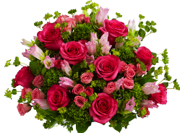

Name: Pink Burst/Tickled Pink/Think Pink
Copy: The perfect bouquet for the pink lover in your life! With a blend of 9 hot pink roses, light pink campanula and bupleurum, this vibrant bouquet will no doubt leave its recipient tickled pink.

B525
5 red roses, 4 white cushion poms, 5 red carnations, 4 ruscus
$39.99

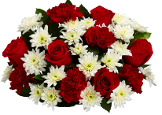

Name: Red Rose Romance/Endless Love/Classic Romance
Copy: An elegant bouquet of classic contrasts, bright red roses and carnations offset by crisp white poms spell cherished, time-honored romance.

M295
3 stargazer lilies, 5 dark pink dianthus, 4 red matsumoto asters, 4 ruscus
$39.99
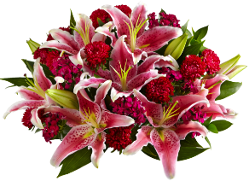

Name: Stargazer Surprise/Surprise & Delight/Star of the Show
Copy: As beautiful to smell as it is to look at, this fresh and fragrant blend of stargazer lilies, deep pink dianthus and vivid red asters surprises and delights multiple senses all at once.

M296
3 white snapdragons, 4 white daisy matricaria, 3 purple kale, 4 pink Asiatic lilies, 4 light pink dianthus, 3 bay laurel
$49.99
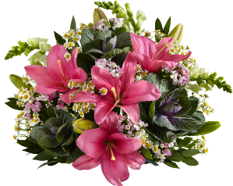

Name: Secret Garden/Daydream Bouquet/Rainforest Bouquet
Copy: Like taking a stroll in a lush garden, this ethereal mix of soft-hued matricaria with bright pink lilies and leafy green kale evokes a romantic whimsy reminiscent of carefree days.

T5112
4 yellow tulips, 4 pink tulips, 4 purple tulips, heart vase
$39.99 bundle- always includes the “you’re sweet” heart vase

**We created this specifically as a less “romantic” option. Geared toward girlfriends sending to each other, or fathers sending to their daughters, etc.

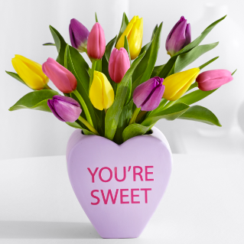

Name: Sweetheart Tulips/Gal Pal Sweetness/You’re Sweet Bouquet
Copy: Let your gal pals know just how sweet you think they are with this mix of bright yellow, pink and purple tulips that is as vibrant and fun as the leading ladies in your life. “You’re Sweet” heart vase included!

New Vases
Please provide multiple name options for each

In general, we do not use the word “vase” in vase names and keep as simple as possible- 2 or 3 words only. You can look at the current vase names on our site to get an idea of what we are looking for.

VA0026
Ceramic vase with watercolor hearts and metallic gold polka dots
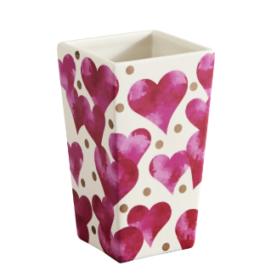
Name: Floating Hearts/Hearts & Dots/Heart to Heart

VA0023
Red glass cylinder with faux bark sleeve that has a cut-out heart and etched arrow

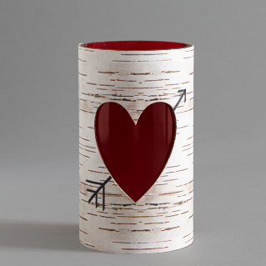

Name: Bark Heart/Rustic Heart/Arrow to the Heart/Cupid Got Me

VA0021
Metal bucket with French inspired label that can be reused as an actual champagne bucket
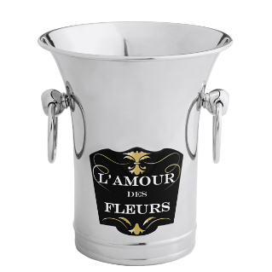

Name: Le Champagne/Parisian Café/Flowers & Bubbly

